Contact:  Anna Schmidt  Römheld Beteiligungsgesellschaft Ltd.  Marketing Manager  Tel: +49 6405 89 254  Mobile: +49 174 3127 740  Email: a.schmidt@roemheld.de  F. Stephan Auch  auchkomm Unternehmenskommunikation  Tel.: 0911 27 47 100  Email: fsa@auchkomm.de | Römheld GmbH  Friedrichshütte  Römheldstraße 1-5  35321 Laubach  Germany  Tel.: +49 (0) 6405 / 89-0  Fax  Email: info@roemheld.de  www.roemheld.de
Press release 1/2026

- ROEMHELD presents new innovative compact clamp with patented kinematics
- For the first time, clamping directly in the smallest closed pockets, grooves and recesses
- No additional clamping points or space required for lever movement
Laubach, 20 January 2026. A newly developed hydraulic compact clamp with horizontal stroke enables direct clamping in the smallest closed pockets, grooves and recesses for the first time. ROEMHELD has optimised the element so that it clamps even workpieces and fixtures in confined spaces with maximum clamping force and high repeat accuracy.
The innovation lies in the kinematics, which are unique worldwide and patented by : The clamping lever first moves horizontally to the point on the workpiece that is to be clamped. It then clamps vertically downwards. This movement sequence allows space-saving workpiece mounting with exact positioning.
Previously, machinists often had to add additional clamping points to components for such clamping tasks and then remove them again in subsequent operations. The new compact clamp avoids the additional costs and extended process times associated with this.
It is particularly suitable for castings, dies, moulds and fixtures that need to be clamped in very narrow grooves, recesses or pockets. Typical applications include multi-sided machining of cast aluminium or grey cast iron workpieces.
Precise and powerful clamping in confined spaces
This new product is available in a space-saving plug-in design. It is offered with either a standard clamping lever or a blank that can be individually adapted to specific workpiece geometries. A quick-fixing mechanism allows for easy changing and increases flexibility for different clamping tasks.
With a clamping force of 6.5 kN at a maximum operating pressure of 220 bar and a horizontal stroke of 8 mm, the hydraulically double-acting clamping element offers high performance despite its minimal dimensions.
The vertical clamping stroke is 4 mm – clamping is possible at any position along the entire stroke. This flexibility enables secure fixing even for workpieces with dimensional tolerances.
Process reliability through integrated controls
For maximum process reliability in automated production environments, the innovation is available in three versions. In addition to a version without position control, variants with pneumatic clamping or unclamping control are also available.
Available immediately
The new compact clamp with horizontal stroke is available now. "With this clamping element, we are solving a problem that many manufacturing companies are familiar with," emphasises Volker Schlautmann, Head of Value Stream at ROEMHELD. "The patented kinematics enable clamping operations that were previously not technically possible or only possible with considerable additional effort. At the same time, the installation position can be flexibly selected, and the plug-in version can be mounted without piping."

About ROEMHELD:
Whether aircraft, automobiles, machine tools or smartphone housings: ROEMHELD technologies and products have been used in the manufacture of numerous industrial goods and consumer goods for over 80 years.
Innovative and smart clamping technology solutions for workpieces and dies in forming technology and plastics processing form the core of the continuously growing portfolio. This is complemented by components and systems for assembly and handling technology, drive technology and automation, as well as interlocks for rotors of wind turbines.
In addition to a constantly growing range of more than 25,000 catalogue items, ROEMHELD specialises in the development and manufacture of customer-specific solutions and is internationally recognised as one of the market and quality leaders.
Innovation through tradition: ROEMHELD has its origins in the Friedrichshütte foundry, founded in 1707, which still belongs to the ROEMHELD Group today and is one of the oldest active industrial companies in Germany.
The owner-managed group of companies employs around 500 people at its three locations in Laubach, Wilnsdorf and Rankweil / Austria and is represented in over 50 countries with service and sales companies. With customers primarily from the mechanical engineering, automotive, aviation and agricultural industries, ROEMHELD generates annual sales of more than 90 million euros.

Photos:
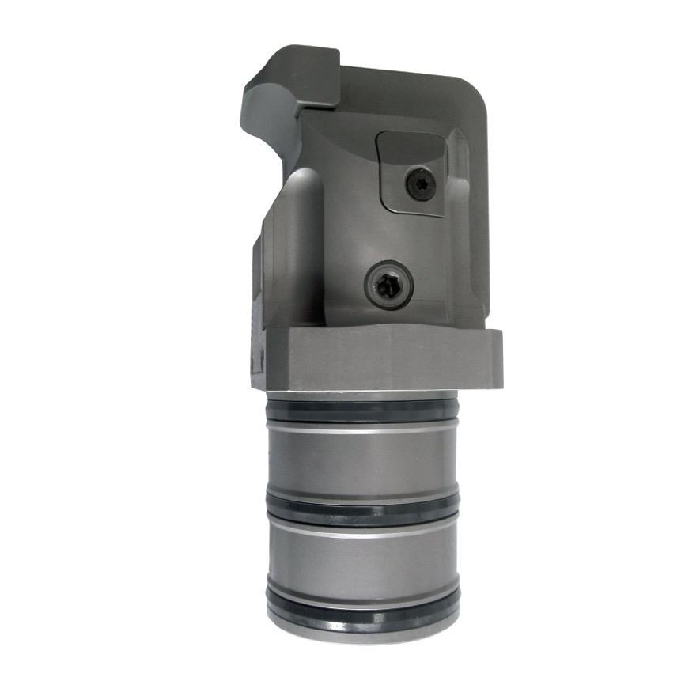
Photo 1:
The new compact hydraulic clamp with horizontal stroke developed by ROEMHELD enables direct clamping in the smallest closed pockets, grooves and recesses for the first time (photo: ROEMHELD).
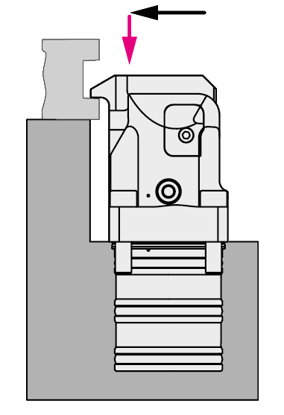
Photo 2:
The innovation lies in the unique, patented kinematics: the clamping lever first moves horizontally towards the workpiece and then clamps vertically downwards (photo: ROEMHELD).

Please send us a copy of any publications:
auchkomm Unternehmenskommunikation, F. Stephan Auch, Hochstraße 11, D-90429 Nuremberg, fsa@auchkomm.de, www.auchkomm.de.

